**AIRLINE PASSENGER SATISFACTION**

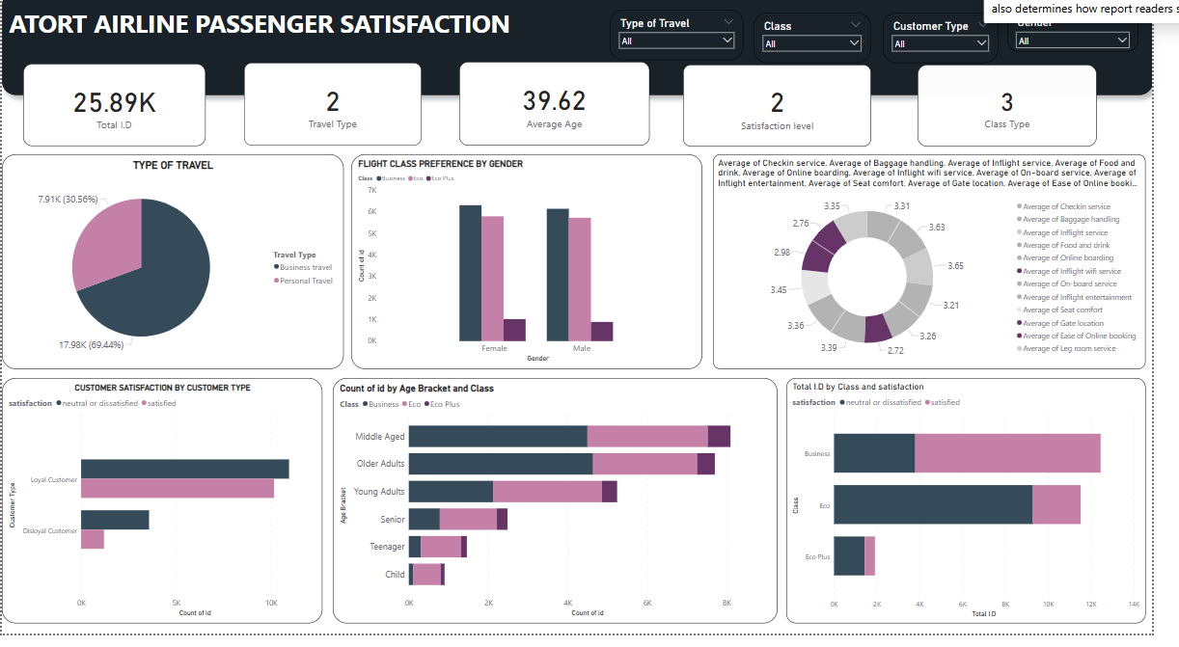

**STEP 1**

* The file was loaded into Excel to understand the data state objectives and clean the data.

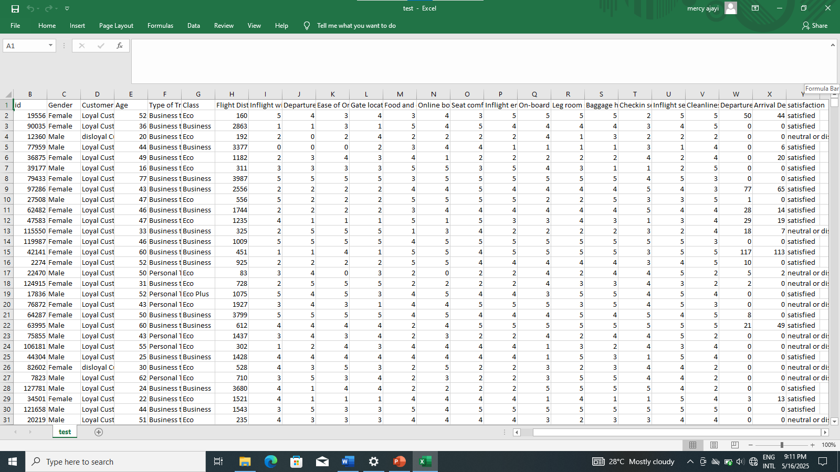

* Loading it into Excel I realized there was a need to group the age column or else I might have visualization problems because there were many ages in the age column, created another column named

“**Age Bracket**” and grouped it using the **IFS** function

( =IF(D2<=12), “Child”, IF(D2<=19), “Teenager”, IF(D2<=29), “Young Adult”, IF(D2<=44), “Middle Aged”, IF(D2<=59), “Older Adult”, IF(D2>59), “Senior”))))))

* I further checked for duplicates and filtered the columns to check for misspellings to correct them using Find and Replace.
* Cleaned data was then saved.

**PROBLEM STATEMENT**: Our airline has some ratio of disloyal customer that remains a challenge due to different expectations of travelers which the company intends to drive to the positive side. The company brought into account rating based on key satisfaction preferences.

Key challenges include:

* Analyzing the ratio of satisfied customers to unsatisfied/neutral customers
* Identifying demographic factors such as gender and age
* Assessing the count of customers across each class
* Understanding a few reasons behind customer disloyalty

**OBJECTIVE**: After conducting an analysis through reviews to identify and address the reasons behind customer dissatisfaction, the objective is to determine the factors that most significantly impact passenger satisfaction ( WiFi, baggage handling, seat comfort, inflight entertainment, on time performance). Identify how to improve operational efficiency such as delays in arrival and departure where the airline is failing to satisfy the passenger’s expectations.

**Step 2**

* In Power Bi I loaded and cleaned the data and transformed it in Power Query to ensure data was cleaned well.
* In Power Query checked to see if every column was in a standardized format.
* There were null values in the “Arrival Delay in Minutes” column, so I replaced them with 0 using the “Replace values” option in the Transform tab.
* Data was then loaded for visualization using the “Close & Apply option in Power Query.

**Step 3(Visualizations)**

* Started with a title Bar using a textbox from the insert tab on the home tab
* Proceeded to visualize our KPIs (Count of customer using id, Average arrival delay in minutes, and Average departure delay in Minutes, Average flight distance and the Number of flight class the airline operates

**INSIGHT**  
  
From the reviews gotten from passengers we deducted that 80.53% are loyal customers while 18.47% are disloyal customers. 42.29% of the loyal customers are unsatisfied with our services while 32.24% are satisfied. 13.32% of disloyal customers are unsatisfied with the service quality while 4.65% are satisfied.  
  
Most of the airline passengers travelled for personal purpose with a percentage of 69.44% while the remaining passengers traveled for business purpose taking 30.56%.

* Created clustered column chart for customer satisfaction level across age brackets

Each customer’s age was categorized from Child, Teenager, Young adults, Middle age, older adult and senior. Customer satisfaction across age group shows that the middle aged are the most dissatisfied amongst the age groups. Comparing all age bracket between the satisfied and unsatisfied/neutral, only older adults have a lower unsatisfied rate to satisfied rate while the other age groups have higher proportion of unsatisfaction to satisfaction ratio

* Created stacked bar chart for customer satisfaction against flight class using the value Count of ID

Passengers that board Economy flight class have a high level of unsatisfaction due to the fact that they are likely not pleased with our operation efficiency. Only a few passengers on business class are not satisfied with the airline service.

* Created stacked bar chart for age bracket by class
* Created donut chart to know the average rating of each review

The range of rating from the review was from 1 – 5, after collating the ratings together we observed that most passengers are not satisfied with the inflight WiFi service with an average rating of 2.72. moreover, passengers also found the online booking rather difficult than it being easy with an average rating of 2.76 from the total review. These two services have the lowest rating value.

* Created a scatter plot chat for the sum of arrival delay minutes and departure delay minutes

Total departure delay minutes against total arrival delay minutes is linear which indicates a direct relationship between the two factors where one factor increases at a relatively constant rate as the other factor increases.

**RECOMMENDATIONS**

* Enhance retention and loyalty rewards for Eco class by developing strategies to increase the stability of passengers by handing out 3-time loyalty cards to passengers in which they tick each time they use the airline for accuracy in which after the 3rd usage they get an upgrade to Business class or accessibility to lounge
* **Easy online booking for flights:** provide simplicity and directions to navigate through the booking process. Create a better website that can allow multiple booking placements at a time to avoid passengers having a hard time booking tickets and offer transparent pricing with no hidden charges.
* Proficient WiFi services: adequate provision of strong Wifi services to passengers as many were dissatisfied with the WIFI services. Ensure the WiFi service is free from technical issues
* Comfortable seating and legroom service: Offer convenient seats with adequate legroom service for passengers.
* Improve operational efficiency by looking into check in issues, arrival delay and departure delay for better passenger convenience.

CONCLUSION

In conclusion the major setbacks derived from the ratings which includes Poor inflight WiFi service and difficulty in online ticket booking among many others which are inflight entertainment, comfortable seating and overall experience. Consistent efforts to address passenger reviews, implement factors to improve operation efficiency will be a great way to increase passenger’s satisfaction and loyalty. Ensuring satisfaction involves an approach that combines optimistic transparency with high quality service will help to meet and exceed passenger’s expectations.